Discovery Report

Volume 3. WAY4 Training

Orient Commercial Bank

Version 1.0

Status: Final

Date: 03.09.2020

Prepared by:

Author:

Approved By: Tu B. Nguyen

1. Table of Contents

1. Table of Contents 2

2. History of changes 3

3. Introduction 4

3.1. Notations 4

4. Introduction 5

4.1. Overview 5

4.2. Training Topic 5

5. Training Requirement 6

5.1. REQTRI001. Issuing Product 6

5.1.1. Business Requirement 6

5.1.2. Technical Details 6

5.2. REQTRI002. POS Acquiring 7

5.2.1. Business Requirement 7

5.2.2. Technical Details 7

5.3. REQTRI003. ATM Acquiring 7

5.3.1. Business Requirement 7

5.3.2. Technical Details 7

5.4. REQTRI004. WAY4 Switching 8

5.4.1. Business Requirement 8

5.4.2. Technical Details 8

6. Reports 9

1. History of changes

|  |  |  |  |
| --- | --- | --- | --- |
| version | date | Description | author |
| 0.1 | 11.08.2020 | Initial Version | Tu B. Nguyen |
| 1.0 | 03.09.2020 | Final version | Tu B.Nguyen |
|  |  |  |  |
|  |  |  |  |
|  |  |  |  |

**Copyright**

© OpenWay Asia Limited 2020. All rights reserved.

The Copyright of this complete document and every part it belongs to OpenWay Asia Limited. Proprietary material, brand or product names of other parties or trademarks remain with their respective owners. You may not, except with our express written permission, distribute or commercially exploit the content. Nor may you transmit it or store it in any other website or other form of electronic retrieval system. Any sample data used in examples below are completely fictitious unless otherwise noted.

**Disclaimer**

This document and the OpenWay Asia software it describes are furnished by OpenWay Asia Limited under a Software Licensing Agreement, Consultancy Agreement, Variation Request or Confidentiality Agreement, and may be used or copied only in accordance with the terms of such Agreement. Neither this document nor the OpenWay Asia software it describes may be used, sold, transferred, copied, translated, reproduced or transmitted in any form or by any means, electronic or mechanical, for any purpose, in whole or in part, other than in accordance with the terms of such Agreement, or otherwise without prior written consent of OpenWay Asia Limited.

This document describes a generic product or service and should be read in conjunction with other documents relevant to the configuration of any specific system. The licensee of OpenWay software or user of OpenWay Asia services is responsible for ensuring that the product or service described herein meets its own requirements

**Confidentiality**

The information contained in this Document is the property of OpenWay Asia Ltd and contains CONFIDENTIAL information that is produced solely for the benefit of the receiving party named on the front page of this document. The recipient should keep this document and all its information confidential. On no account should this document, in whole or in part, be used, sold, transferred, copied, translated, reproduced or transmitted in any form or by any means, electronic or mechanical, or disclosed or disseminated to any third party, without the express written permission of OpenWay Asia Ltd.

1. Introduction

This document contains the WAY4 Training Services which the WAY4 Topic will be trained with in order to meet the Training Requirements of Orient Commercial Bank. It covers the different sections of the WAY4 Training Topic needed to be done in them.

* 1. Notations

Notations used in this document are listed in the table below.

***Table 1. Notations***

| Notation | Description |
| --- | --- |
| N | Numeric digits 0 through 9 |
| AN | Alphabetic and Special Characters |
| DT | Date + Format in field description |
| B | Binary representation of data |
| NVAR | Variable length data up to nn characters. There will be two or three character length (depending upon whether maximum data length is 99 or 999) at the beginning of the element to identify the number of positions following to the end of the data element |
| M | Mandatory |
| O | Optional |
| C | Conditional |
| NPA | NAPAS (National Payment Switch) |
| LC | Local Card |
| OCB | Orient Commercial Bank |
| OPW | OpenWay |

1. Introduction

## Overview

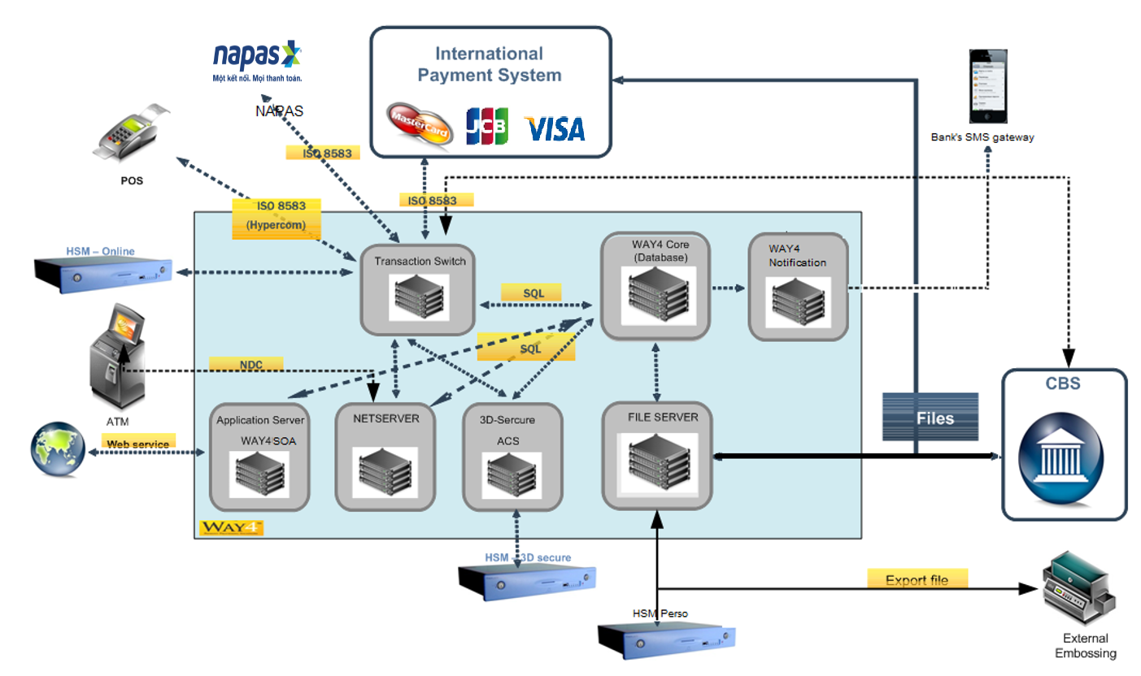WAY4 system was implement on the year 2018. All cardholder and merchant data were migrated from legacy system to WAY4 system. WAY4 system is running until now.

## Training Topic

After 2 years, OCB need to upgrade WAY4 knowledge for end-user, operation and technical guys in order to maintain/monitor WAY4 system smoothly. Therefore, OCB request OpenWay contribute the WAY4 Training Service to enhance WAY4 knowledge for OCB’s employee. Below is high-level training topics.

|  |  |  |  |
| --- | --- | --- | --- |
| No | requirement | TOPIC | description |
| 1 | REQTRI001 | Issuing Product | Service Package, Tariff, Event Type, Classifier Action… |
| 2 | REQTRI002 | POS Acquiring | POS product and Merchant Registration |
| 3 | REQTRI003 | ATM Acquiring | ATM Fee and ATM Monitoring |
| 4 | REQTRI004 | WAY4 Switching | Transaction flow and WAY4TS Routing |

1. Training Requirement

## REQTRI001. Issuing Product

### Business Requirement

OCB requests OpenWay provides the training topic by below business requirement.

* Introduce to WAY4 object: Service Package, Tariff, Event Type, Classifier Action.
* Configure the parameter of cash withdrawal, fee, usage and overdraft.
* Configure PIN Change for particular card product.
* Configure non-physical prepaid card product.
* Configure Loyalty.
* Configure to on/off the feature as cash withdrawal, retail, ecom
* Configure to discount for n-th first transactions in period.
* Guide XML format file to issue cards by batch.

Sample product for training is used

* MC EMV Platinum Credit Main Card
* KYC Prepaid Card

### Technical Details

Openway will provide the training section as below schedule:

|  |  |  |
| --- | --- | --- |
| No | TOPIC | description |
| 1 | Way4 Iss Product | Introduce Basic concept of WAY4 Issuing Product Objects. |
| 2 | Way4 Service Pck | Configure the parameter of cash withdrawal, fee, usage and overdraft.  Configure PIN Change for particular card product.  Configure to on/off the feature as cash withdrawal, retail, ecom |
| 3 | Way4 Service Pck | Configure to discount for n-th first transactions in period  Configure Loyalty |
| 4 | Way4 Product | Configure non-physical prepaid card product. |
| 5 | Way4 Batch File | Guide XML format file to issue cards by batch. |

## REQTRI002. POS Acquiring

### Business Requirement

OCB requests OpenWay provides the training topic by below business requirement.

* Configure POS Parameters, GL setup in WAY4.
* Configure MDR for each merchant.
* Register Merchant in WAY4.
* Merchant settlement.

### Technical Details

Openway will provide the training section as below schedule:

|  |  |  |
| --- | --- | --- |
| No | TOPIC | description |
| 1 | Way4 POS Product | Configure POS Parameters, GL setup in WAY4.  Configure MDR for each merchant. |
| 2 | Merchant Registration | Register Merchant in WAY4  Merchant settlement |

## REQTRI003. ATM Acquiring

### Business Requirement

This section describes OCB’s training requirement for ATM Acquiring.

* Guide to setup ATM module
* Setup ATM Acquiring Fee
* Guide ATM Management and Monitoring.

### Technical Details

Openway will provide the training section as below schedule:

|  |  |  |
| --- | --- | --- |
| No | TOPIC | description |
| 1 | Way4 ATM Product | Guide to setup ATM module  Setup ATM Acquiring Fee |
| 2 | ATM monitoring | Guide ATM Management and Monitoring |

## REQTRI004. WAY4 Switching

### Business Requirement

This section describes OCB’s training requirement for Way4 Switching.

* WAY4 System Overview.
* WAY4 Transaction flow and Routing.
* Guide to change WAY4TS Routing Service.

### Technical Details

Openway will provide the training section as below schedule:

|  |  |  |
| --- | --- | --- |
| No | TOPIC | description |
| 1 | Way4 System Overview | WAY4 System Overview |
| 2 | Way4 Authorization | Basic concept of Way4 authorization  Auth/Fin document (all doc) & Transaction Type |
| 3 | Way4 Routing | WAY4 Transaction flow (on-us, off-us, 3dsecure) and Routing  Guide to change WAY4TS Routing Service |

1. Reports

No report is requested.